H.T No
Regulations:
A14

Sreenidhi Institute of Science and Technology
(An Autonomous Institution)
Code No: 4B203 Date: 14-July-2021 (AN)

B.Tech I-Year II- Semester External Examination, July-2021 (Supplementary)
ENGINEERING MECHANICS (ME)

Time: 3 Hours Max.Marks:70

Note: a) No additional answer sheets will be provided.
b) All sub-parts of a question must be answered at one place only, otherwise it will not be valued.
c) Missing data can be assumed suitably.

ANSWER ANY 5 OUT OF 8 QUESTIONS. EACH QUESTION CARRIES 14 MARKS.

Bloom's Cognitive Levels of Learning (BCLL)

Remember | L1 | Apply | L3 | Evaluate | L5
Understand | L2 | Analyze | L4 | Create | L6

 |  |  | BCLL | CO(s) | Marks
1. |  | Two smooth spheres of each radius 100 mm weighing 100 N, rest in a horizontal channel having vertical walls, the distance between which is 360 mm. Find the reactions at the points of contacts A,B,C and D as shown in figure.  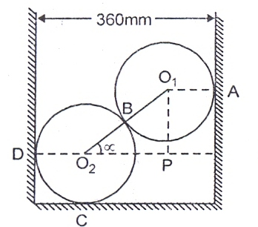 | L4 | CO1 | [14M]
2. |  | Two wedge blocks A and B are employed to raise the load of 2000N resting on another block C by the application of force P as shown in figure. Neglecting the weights of the wedge blocks and assuming coefficient of friction 0.25 for all surfaces, determine the value of P for impending upward motion of block C.  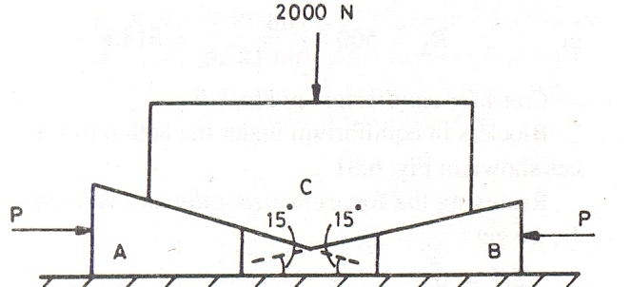 | L4 | CO2 | [14M]
3. |  | Determine the forces in all members of the truss shown in figure and indicate the magnitude and nature of forces on the diagram of the truss . All inclined members are at 60⁰ to the horizontal and length of each member is 2 m.  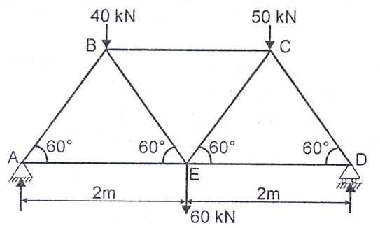 | L3 | CO3 | [14M]
4. |  | Determine the centriod of the parabolic spandrel area shown in figure with respect to the axes shown in figure from first principles  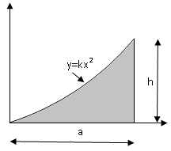 | L4 | CO4 | [14M]
5. |  | Determine the moment of inertia of the symmetric I section as shown in figure about its centroidal axes x-x and y-y . All dimensions are in mm  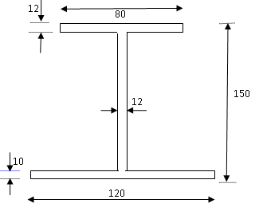 | L5 | CO5 | [14M]
6. |  | Find the moment of inertia of a circular plate of radius R and thickness t about its centrodial axis | L4 | CO6 | [14M]
7. |  | A man weighing W Newton entered a lift which moves with an acceleration of a m/sec². Find the force exerted by the man on the floor of lift when,  i) Lift is moving downward ii) Lift is moving upward | L3 | CO3 | [14M]
8. |  | A small block starts from rest at point A and slides down the inclined plane as shown in Fig. What distance along the horizontal plane will it travel before coming to rest? The coefficient of kinetic friction between block and either plane is 0.3. Assume initial velocity with which it start to move along BC is of the same magnitude as that gained in sliding from A to B.  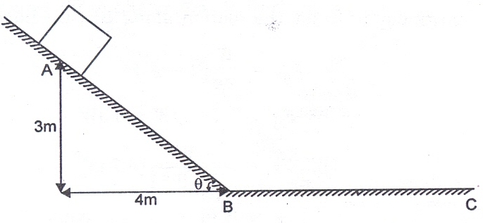 | L4 | CO4 | [14M]

-- 00 -- 00 –

